Department of Computer Science
Amrita School of Computing, Amritapuri Campus
B Tech CSE (2022 Admission)

19CSE499 PROJECT PHASE-II

PROJECT PROPOSAL SUBMISSION

Group Number: C7 Team Members:
Dinesh Venkata vali | AM.EN.U4CSE22215
Kowshik padala | AM.EN.U4CSE22245
Thota Rahul | AM.EN.U4CSE22257
Peruri Teja sai sathwik | AM.EN.U4CSE22271

Project Guide : Dr. Simi Surendran

Project Title : Deep Learning-Based Diagnostic Assistant for Lung Nodule Detection with LLM Integration

Novelty: The novelty of this project lies in the development of an offline-first, edge-deployable AI system for lung nodule screening tailored for rural healthcare environments.
Phase-I established a complete end-to-end prototype capable of ingesting CT scans, generating structured AI findings, and producing bilingual clinical and patient reports. Phase-II advances this novelty by introducing lightweight deep learning models, resource-aware deployment, explainable AI outputs, and health data interoperability.
The system uniquely combines:
- Edge-optimized lung nodule detection and segmentation
- Trust-oriented explainability using visual evidence and uncertainty estimation
- Bilingual reporting for accessibility
- ABDM/FHIR-compliant medical data exchange
Together, these contributions result in a practical, scalable, and socially impactful healthcare AI solution suitable for deployment in Health ATMs.

S8 Objectives:
- To develop a lightweight and efficient lung nodule detection and segmentation pipeline suitable for edge devices.
- To incorporate risk classification and uncertainty estimation for improved clinical reliability.
- To integrate explainable AI mechanisms such as visual saliency and mask overlays to enhance trust.
- To generate structured clinician reports and bilingual patient summaries from AI outputs.
- To enable FHIR/ABDM-compliant interoperability with healthcare systems.
- To evaluate system performance in terms of accuracy, latency, reliability, and usability.

Novelty - Objective mapping:
Novel Aspect | Mapped Objective(s)
Edge-ready AI models for CT analysis | S8-Objective 1
Explainable AI with uncertainty routing | S8-Objectives 2, 3
Bilingual clinician and patient reports | S8-Objective 4
Offline-first Health-ATM deployment | S8-Objective 1,6
ABDM / FHIR interoperability | S8-Objective 5
End-to-end rural healthcare integration | S8-Objective 1,2,3,4,5,6

- Scope of the Project (S8)

• Primary Focus
• The project focuses on building a deployable AI system that performs automated lung CT analysis and delivers clinically meaningful results in resource-constrained rural healthcare settings.

• Key Scope Elements

• Architecture & Design
- Modular AI pipeline for detection, segmentation, and risk estimation
- Edge-compatible design using lightweight neural networks
- Backend orchestration using asynchronous job queues

• Data Management
- Use of public datasets: LIDC-IDRI, LUNA16, LNDb v4, CT-RATE
- Strict preprocessing with slice thickness ≤ 2.5 mm
- Reproducible dataset handling using DVC

• AI & Machine Learning
- Lung region extraction and nodule segmentation
- Malignancy risk prediction
- Uncertainty estimation for clinical review routing

• Explainability
- Grad-CAM and mask-based visual explanations
- Faithfulness evaluation of explanations

• Reporting
- Structured clinician PDF reports
- Simplified bilingual (English + Hindi) patient summaries

• Interoperability
- FHIR DiagnosticReport and ImagingStudy generation
- ABDM sandbox-based data exchange

• Evaluation
- Accuracy, Dice score, ROC-AUC
- End-to-end latency
- Reliability under offline condition.

• Limitations & Boundaries
- Focused on screening support, not final diagnosis
- Uses publicly available datasets for validation
- ABDM integration limited to sandbox testing in Phase-II
- Deployment tested on limited hardware configurations

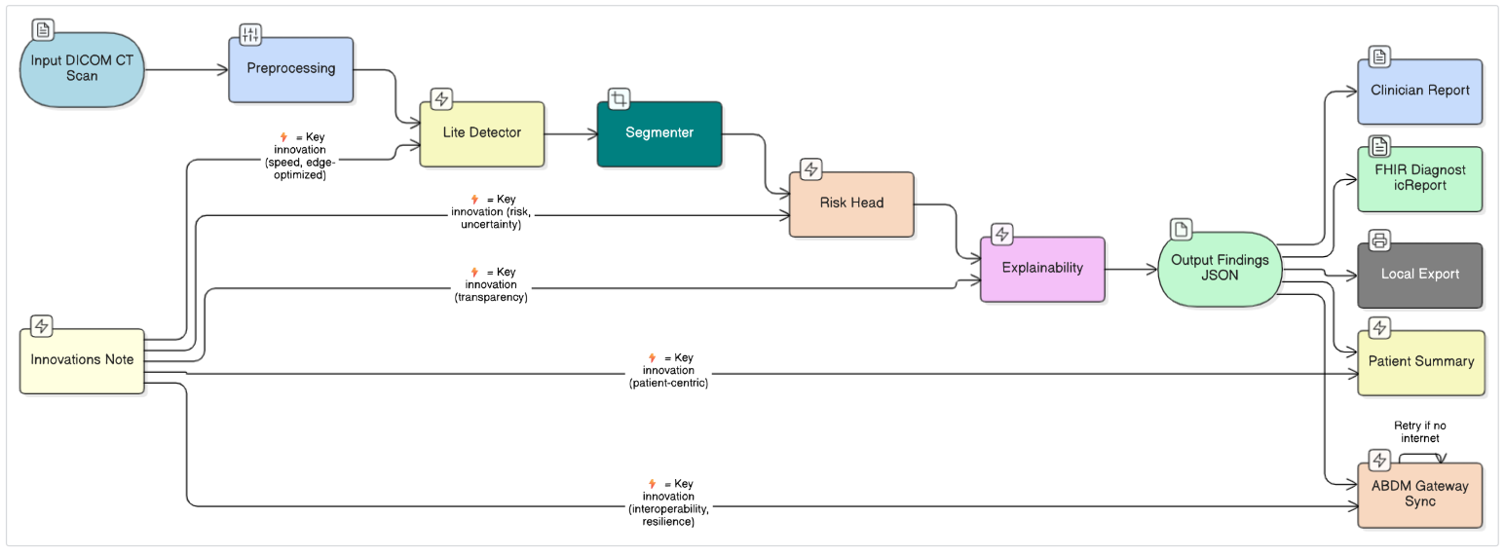
Block Diagram

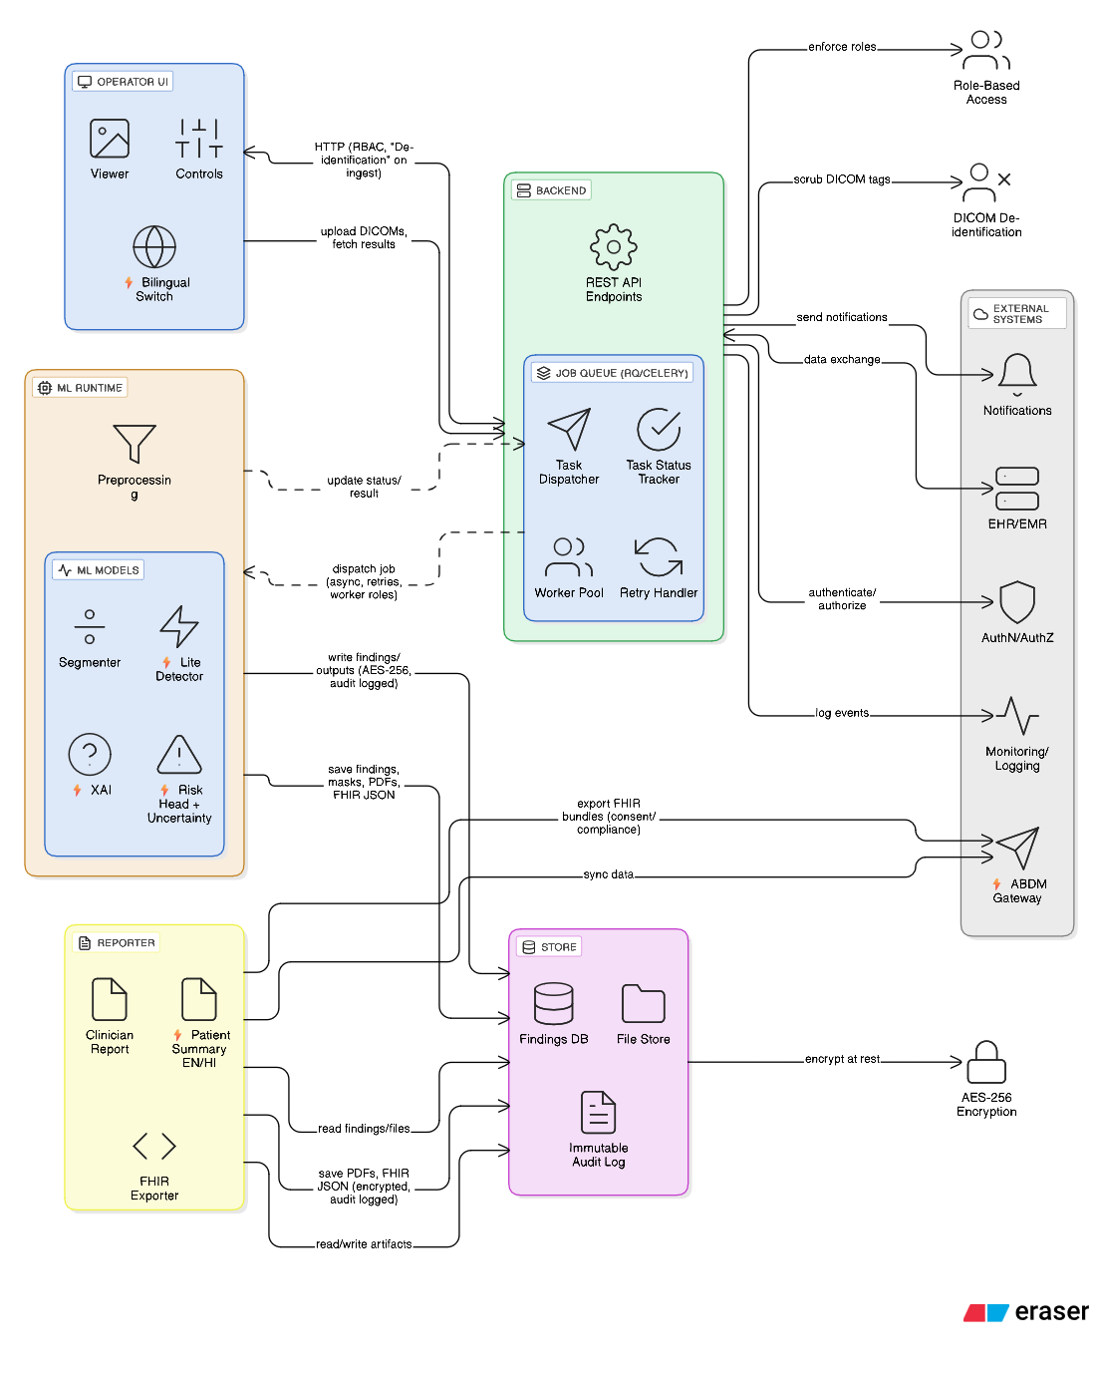
Architecture Diagram (Containers & Components)

Flow Diagram:
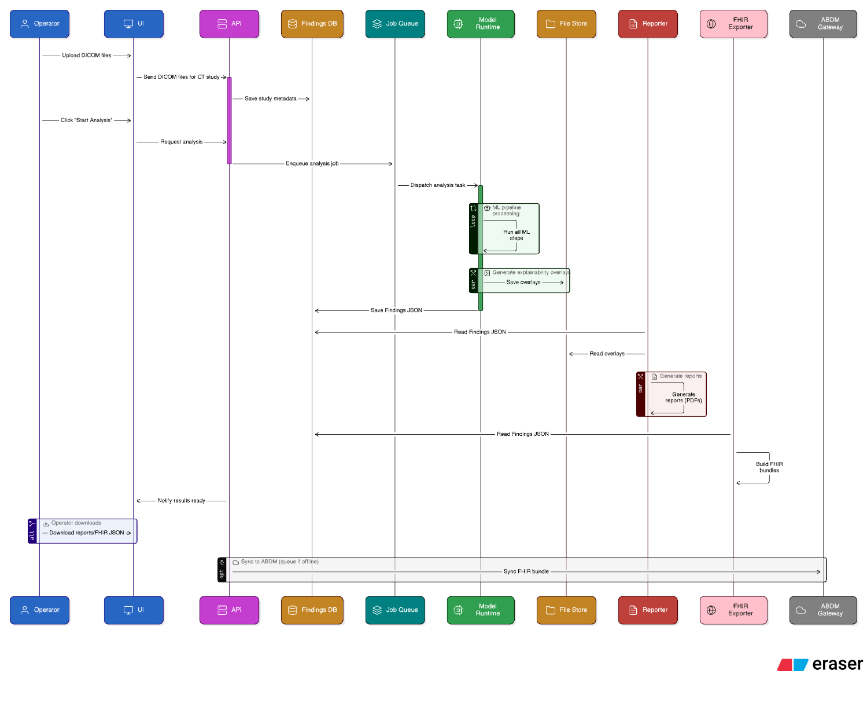
Design- Objective mapping :

Design Component | Maps to S8 Objective(s) | Implementation Details
CT Ingestion Module | Obj-1, Obj-6 | Secure upload, metadata linking
AI Segmentation Pipeline | Obj-1 | - Mobile-UNet based segmentation
Risk Classification Module | Obj-2 | - Lightweight classifier with uncertainty
Explainability Engine | Obj-3 | - Grad-CAM and mask overlays
Report Generation System | Obj-4 | - Jinja2 + PDF rendering
FHIR Export Module | Obj-5 | ABDM-compliant JSON bundles
Monitoring & Logging | Obj-6 | - Latency, errors, audit logs

Signature of the guide:


